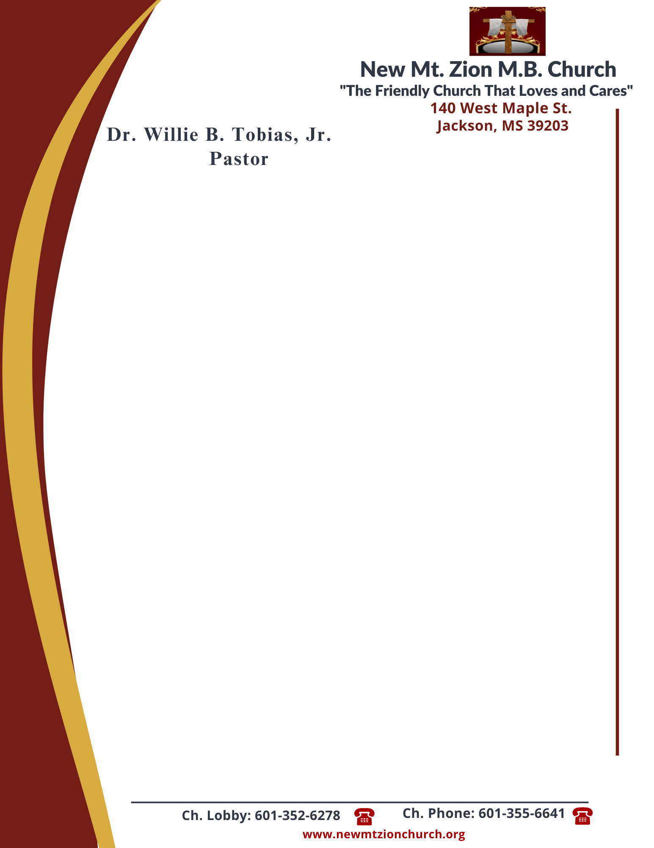

May 15, 2023 “I Am God Alone ”
Exodus Chapter 10:24-29

1. In reading verses 24-26, What did Pharaoh summoned Moses to do and what did he still forbid? What does Moses say may not be left behind? (Sis. Marion Henderson)

2. In the final verses 27-29, Pharaoh displays a true manisfestation of pride and threatens Moses. What is Moses threatened with and how does Moses respond? (Deacon Sammie Wilson)

“The Lord Gave Favor”
Exodus Chapter 11:1-10
Exodus Chapter 11 outlines the most fearsome plaque. The Lord tells Moses that he is going to bring a final plague upon Egypt. This chapter focuses on Pharaohs declaration to Moses; the Lords response to Pharaoh through Moses; and the many opportunities the Egyptians had to put trust in the Lord, and by their choosing to disobey, ultimately faced terrible consequences.

3. What would the result be of the final plague for the Israelites? How would Pharaoh respond to the last plague? Why did God ask the Israelites to request gold and silver from their neighbors and why would their neighbors actually give it to them, verses 1-3? (Sis Genetra Robinson)

4. What would the tenth and final plague be and why did God send such a serious plague on the Egyptians? Do you think the Egyptians had any chance to avoid this fate, verses 4-8? (Dr. Jennifer Taylor).

5. In verses 9-10, why did Pharaoh refuse to listen to Moses as he remained reluctant to concede to the Lord? What can we learn about pride in these verses? (Sis. Carolyn Fleming)

BONUS: List the ten plagues and give the meaning and purpose of each? What does Exodus 11:3 reveal as God’s ultimate purpose of the plagues? What lessons can we, as believers, learn from this? ( Dr. Hymethia Thompson)

