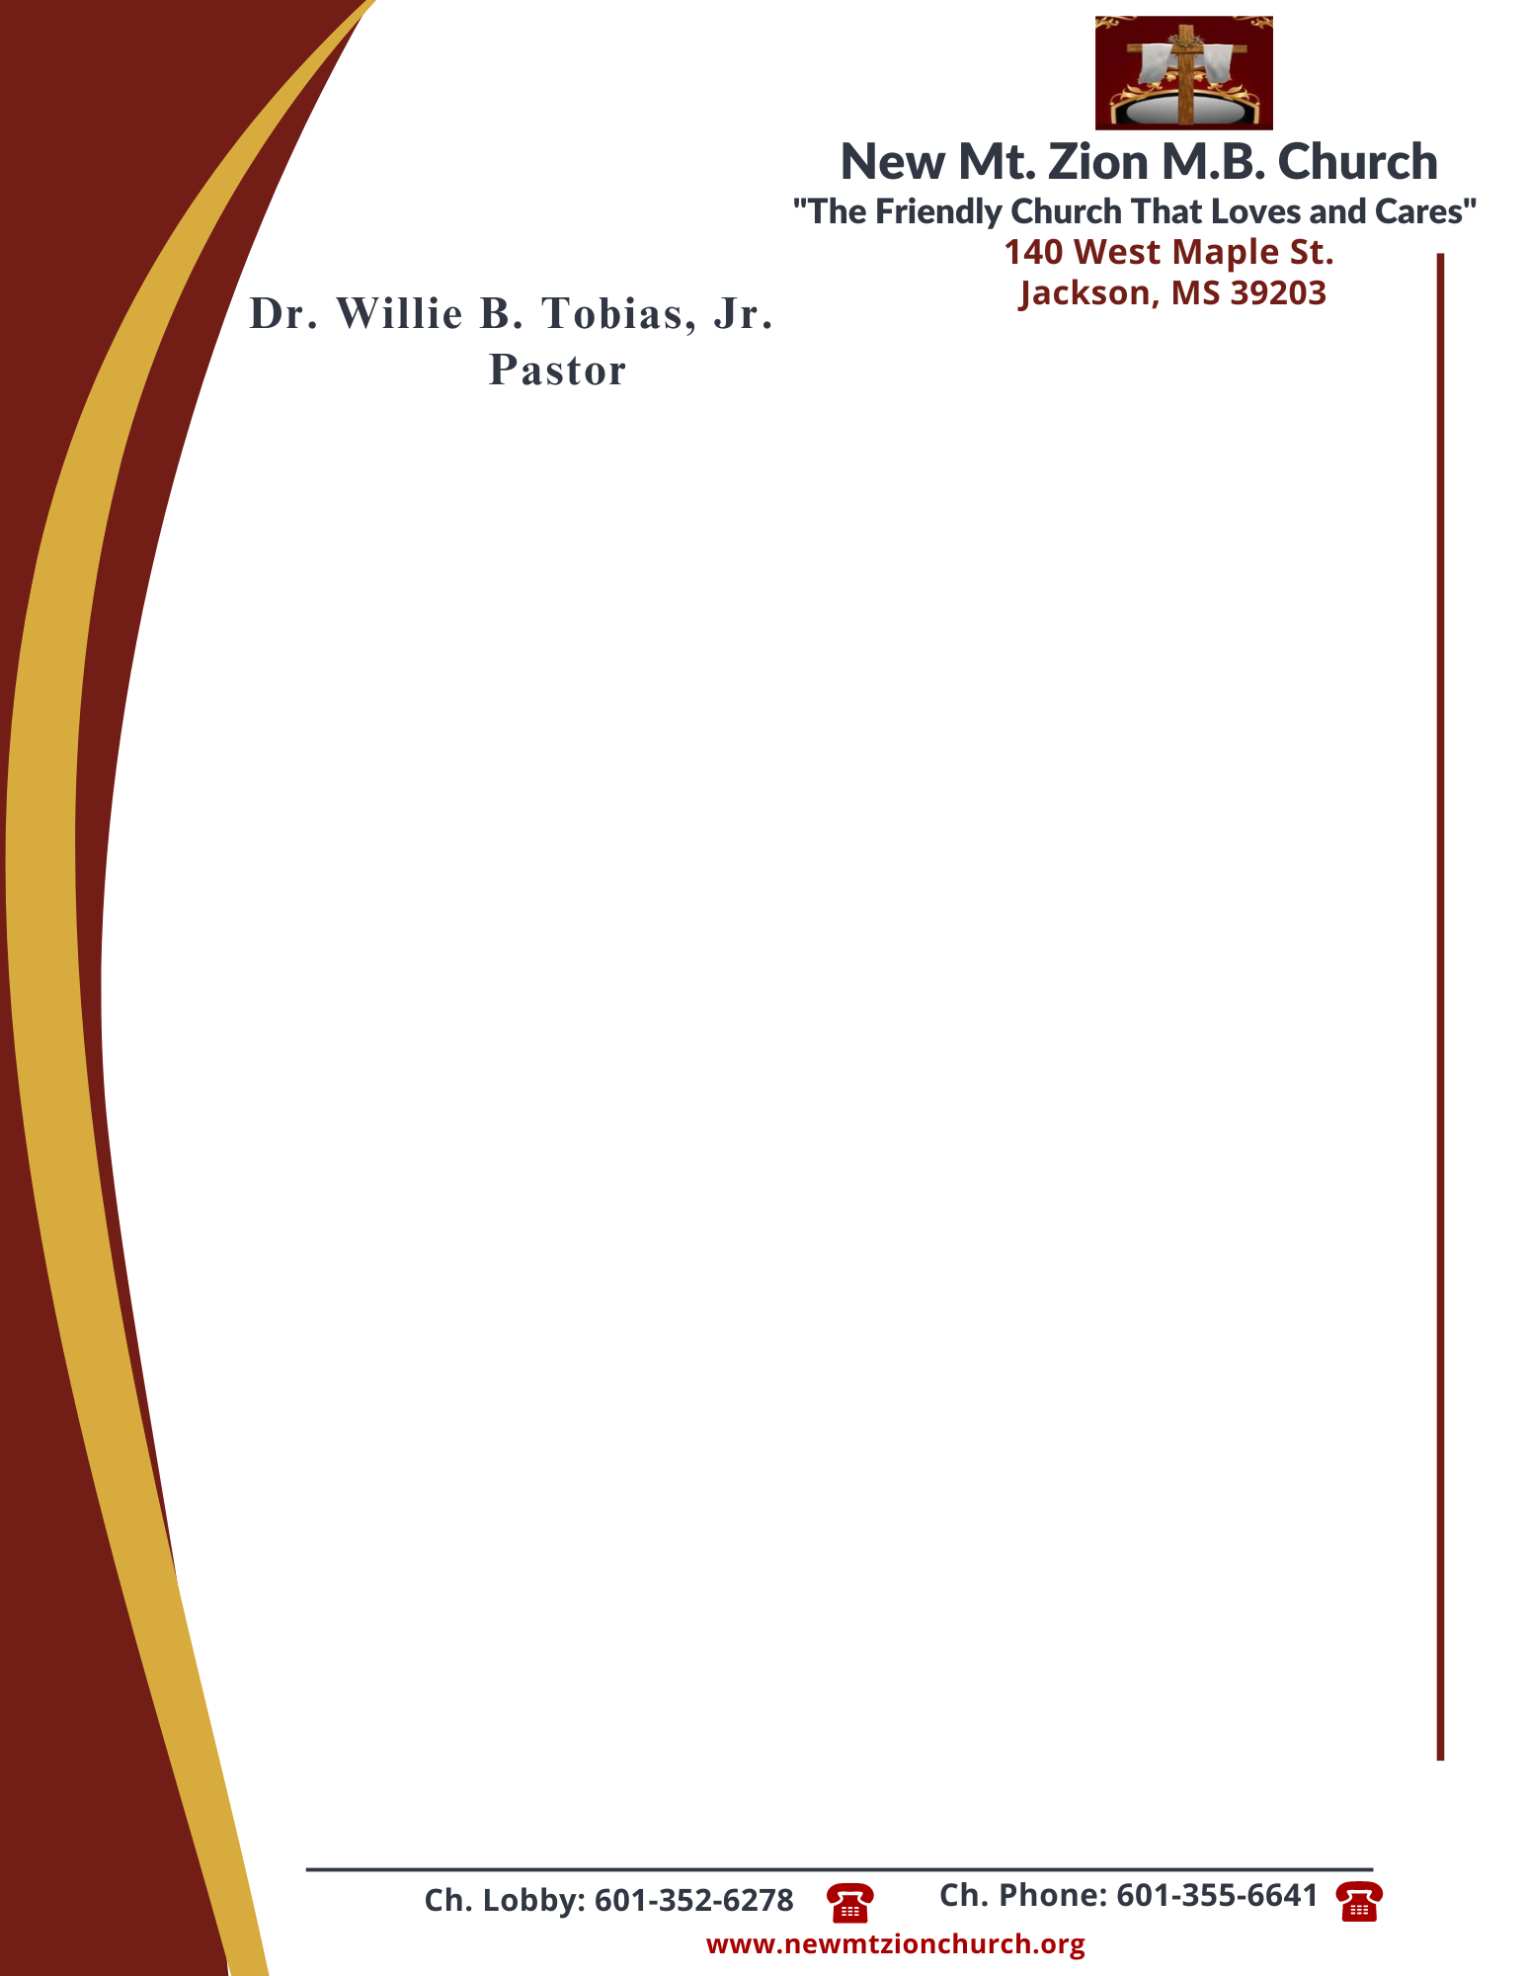

March 25, 2024

“A CONTINUATION OF LAWS AND JUDGEMENTS”
Exodus 22: 1-31

- In reading verses 21-24, what was the law concerning orphans and widows? What was the reason behind this law? (Sis. Hazel Jordan)

- In reading verses 25-27, there was the law governing loans to the needy. How do these verses relate to Luke chapter 6 verses 34-35? What are some of the purposes behind this law? (Sis. Carolyn Miller)

- There was a law governing the cursing of God and rulers. Briefly discuss verse 28. Should we respect bad leaders? How does this verse relate to Romans 13:1? (Dec. Vernell Fleming)

- In reading verses 29-30, briefly discuss the law governing man’s offerings to God. The law was clear: a man was not to keep, not even hold back, the offering. Why is this difficult for many to do today? (Sis. Genetra Robinson)

- In verse 31, there was the law governing livestock killed by wild animals. Briefly discuss what is meant in this verse. (Sis. Hattie Jennings)

