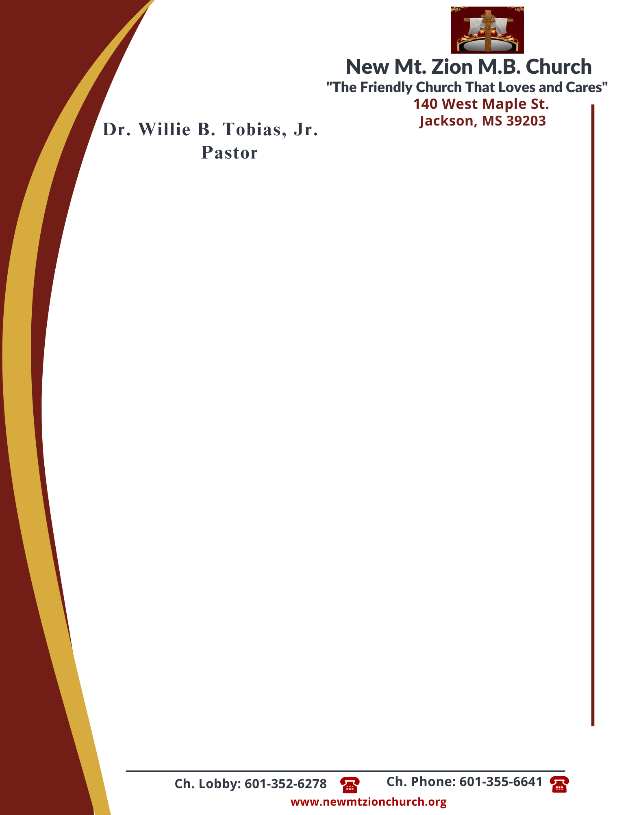

February 19, 2024

“The Laws Governing Human Rights”
Exodus 21: 1-36
This chapter begins a three chapter record of various laws given to Israel by God. These laws are called “judgments.” They are not so much laws regulating conduct as they are laws regulating the sentence upon misconduct.

- In reading verses 33-36, briefly discuss the laws governing the loss or damage to other people’s property. What is fair, just, and equitable when property is lost or damaged?
- (Dr. Jennifer Taylor)

LAWS GOVERNING THEFT: THE STEALING OF PROPERTY (LIVESTOCK)
Exodus 22: 1-15
One of the principle purposes of criminal law is the protection of a person and his property, whether animal, machine, building, land, or any other possession.
- In reading verses 1-4, what was a thief required to repay? Why was this amount so much? Why did the thief have to repay more for the ox than they had to repay for the sheep? (Rev. Herbert Broome)

- In reading verse 5 and 6, how do these verses teach us that we are not only responsible for the harm we do throughout life, but for the harm we allow? (Sis. Carolyn Fleming)

- In reading verses 7-15, how do these laws govern how money or goods were to be treated when given over to the care of another person? (Sis. Rosa Todd)

