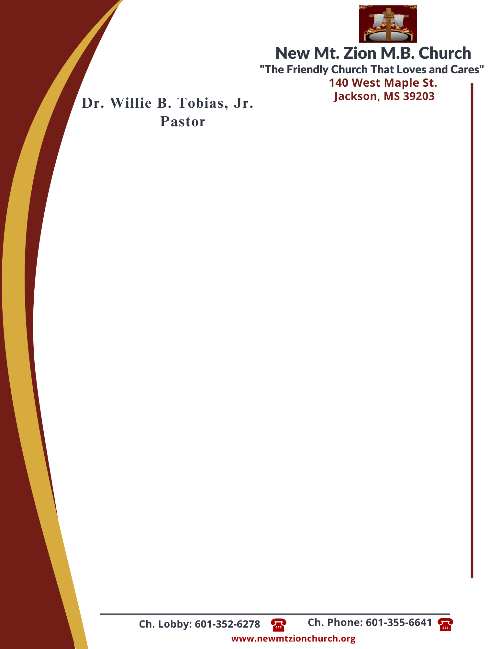

April 1, 2024

“A CONTINUATION OF LAWS AND JUDGEMENTS”
Exodus 22: 1-31

- In reading verses 29-30, briefly discuss the law governing man’s offerings to God. The law was clear: a man was not to keep, not even hold back, the offering. Why is this difficult for many to do today? (Sis. Genetra Robinson)

- In verse 31, there was the law governing livestock killed by wild animals. Briefly discuss what is meant in this verse. (Sis. Hattie Jennings)

“The Law Governing Justice and Mercy in Court and Among Neighbors”
Exodus 23: 1-9

- In reading verses 1-3, there was the law governing slander. Briefly define slander and what is being stated in these verses. Why would anyone want to protect a person by lying for him? (Sis. Peggy Jennings)

- Verse 4 & 5 gives us the law governing the treatment of enemies. Why is this law one of the most difficult laws for people to understand and follow? (Sis. Rosa Todd)

- In reading verses 6 & 7, there is the law governing justice to the poor. Why is it necessary for society to guarantee justice and fairness to the poor? (Deacon Sammie Wilson)

