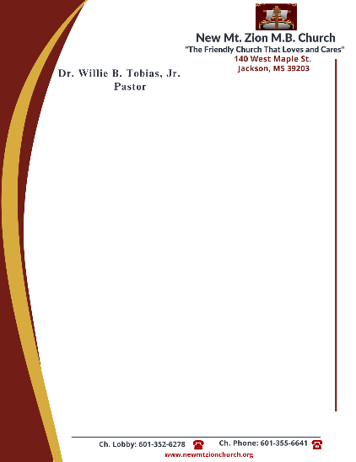

December 4, 2023

“Continuation of The Law”
Exodus 20: 1-26
The world offers various opinions. Is it left up to man to formulate his own values, his own system of morality and ethics?

- How does one’s name reflect their nature? How do you think we are misusing GOD’S name today? (Sis. Genetra Robinson)

- Verses 8-11, gives reference to the Sabbath day. When did GOD initially create a day of rest? Why has obeying this commandment become a challenge to some? (Sis. Monica Tobias)

- In reading verse 12, what does it mean to honor our parents? Briefly describe the promise is attached to this commandment. (Deacon Sammie Wilson)

- Briefly interpret verse 13, can a murderer be saved and forgiven for their sin of murder? (Sis. Doris Powell)

- Briefly interpret verse 14. How does this commandment coincide with Matthew 5:27-28? (Rev. Venus Jones)

- Briefly interpret verse 15. List various ways people steal. (Sis. Charlotte Cannon)

