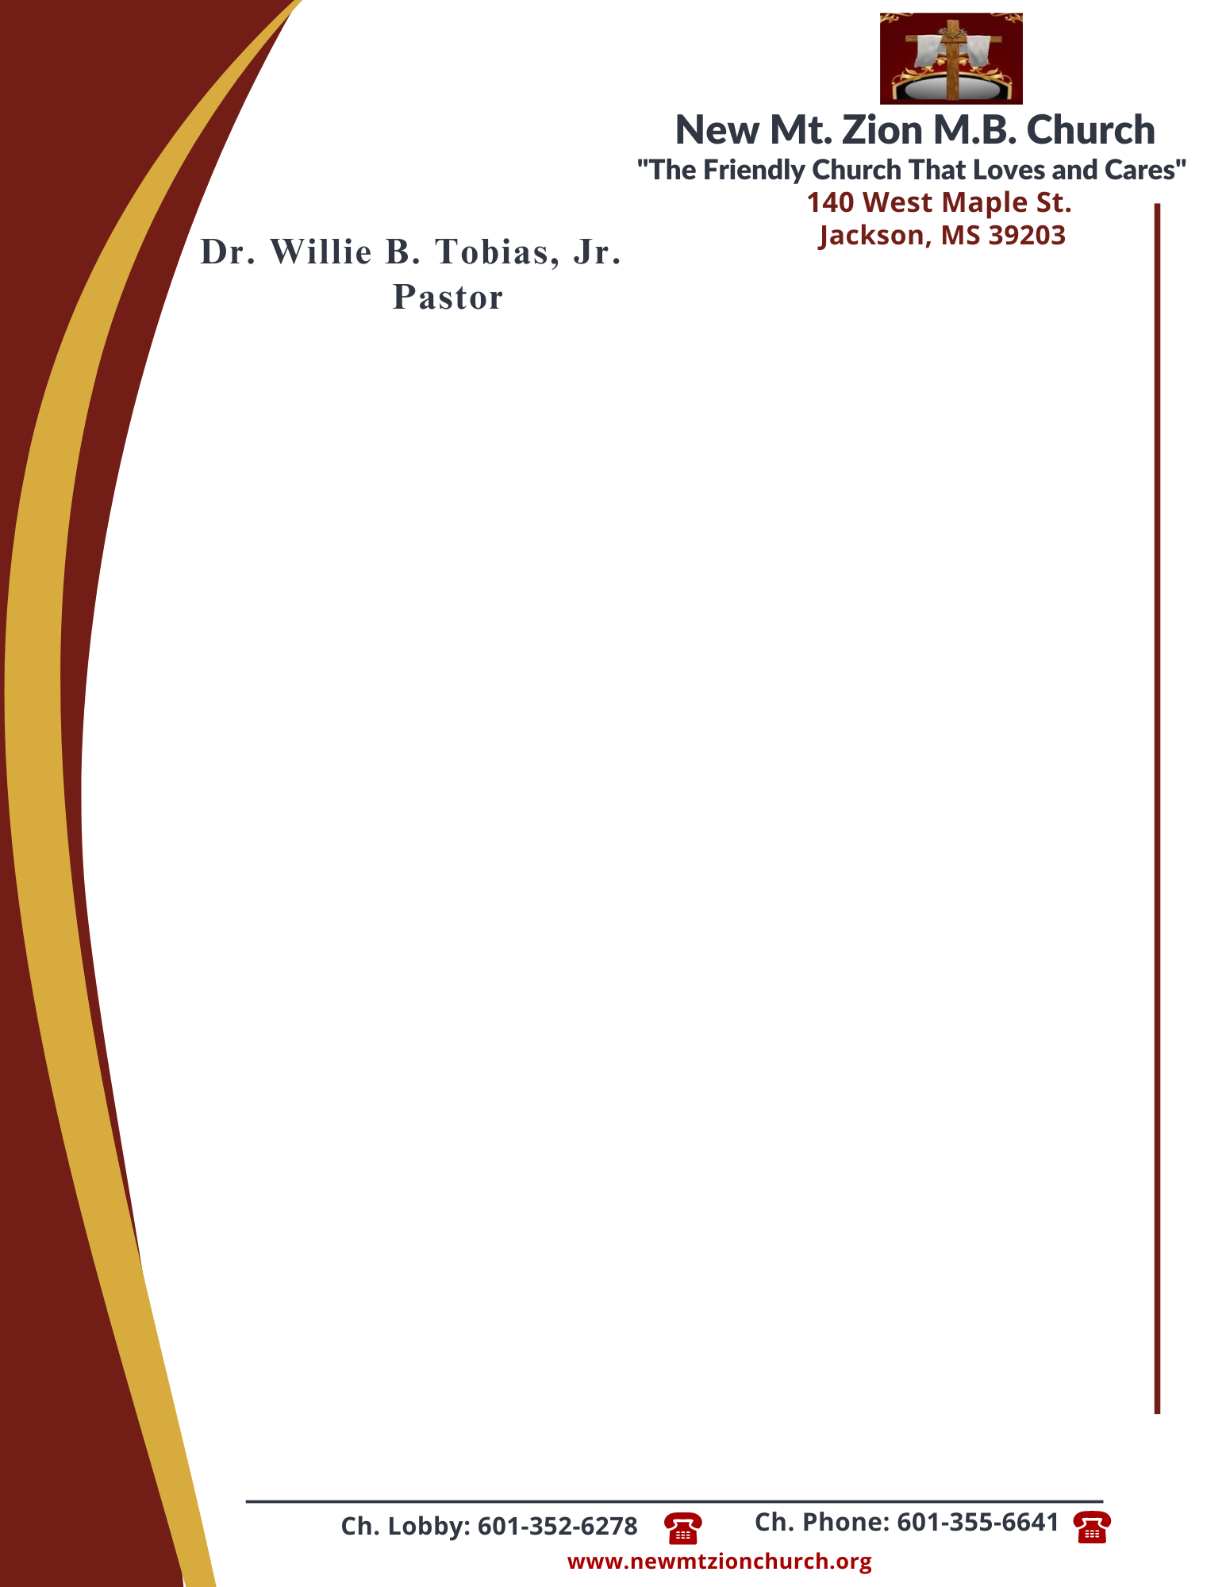

January 29, 2024

“The Laws Governing Human Rights”
Exodus 21: 1-36
This chapter begins a three chapter record of various laws given to Israel by God. Chapter 21 through 23 is all one section. These laws are called “judgments.” They are not so much laws regulating conduct as they are laws regulating the sentence upon misconduct.

- In reading verses 7-11, briefly discuss the laws governing the Hebrew female slave. How or why is the female slave treated differently than the male slave? (Dec. James Todd)

- What is the difference between premeditated murder and manslaughter? In reading verses 12-14, what are the judgements stated? ( Dec, Esther McCoy)

- Why is a child/parent relationship important to God? What does GOD say about this relationship in verses 15-17? (Kimberly Austin)

- Briefly define restitution. In reading verses 18-19, when should restitution take place or be given? (Sis. Juanita Taylor)

- Briefly discuss the laws or judgements mentioned in verses 20-26? What would happen if a slave was permanently injured by their master? (Sis. Idetra Berry)

