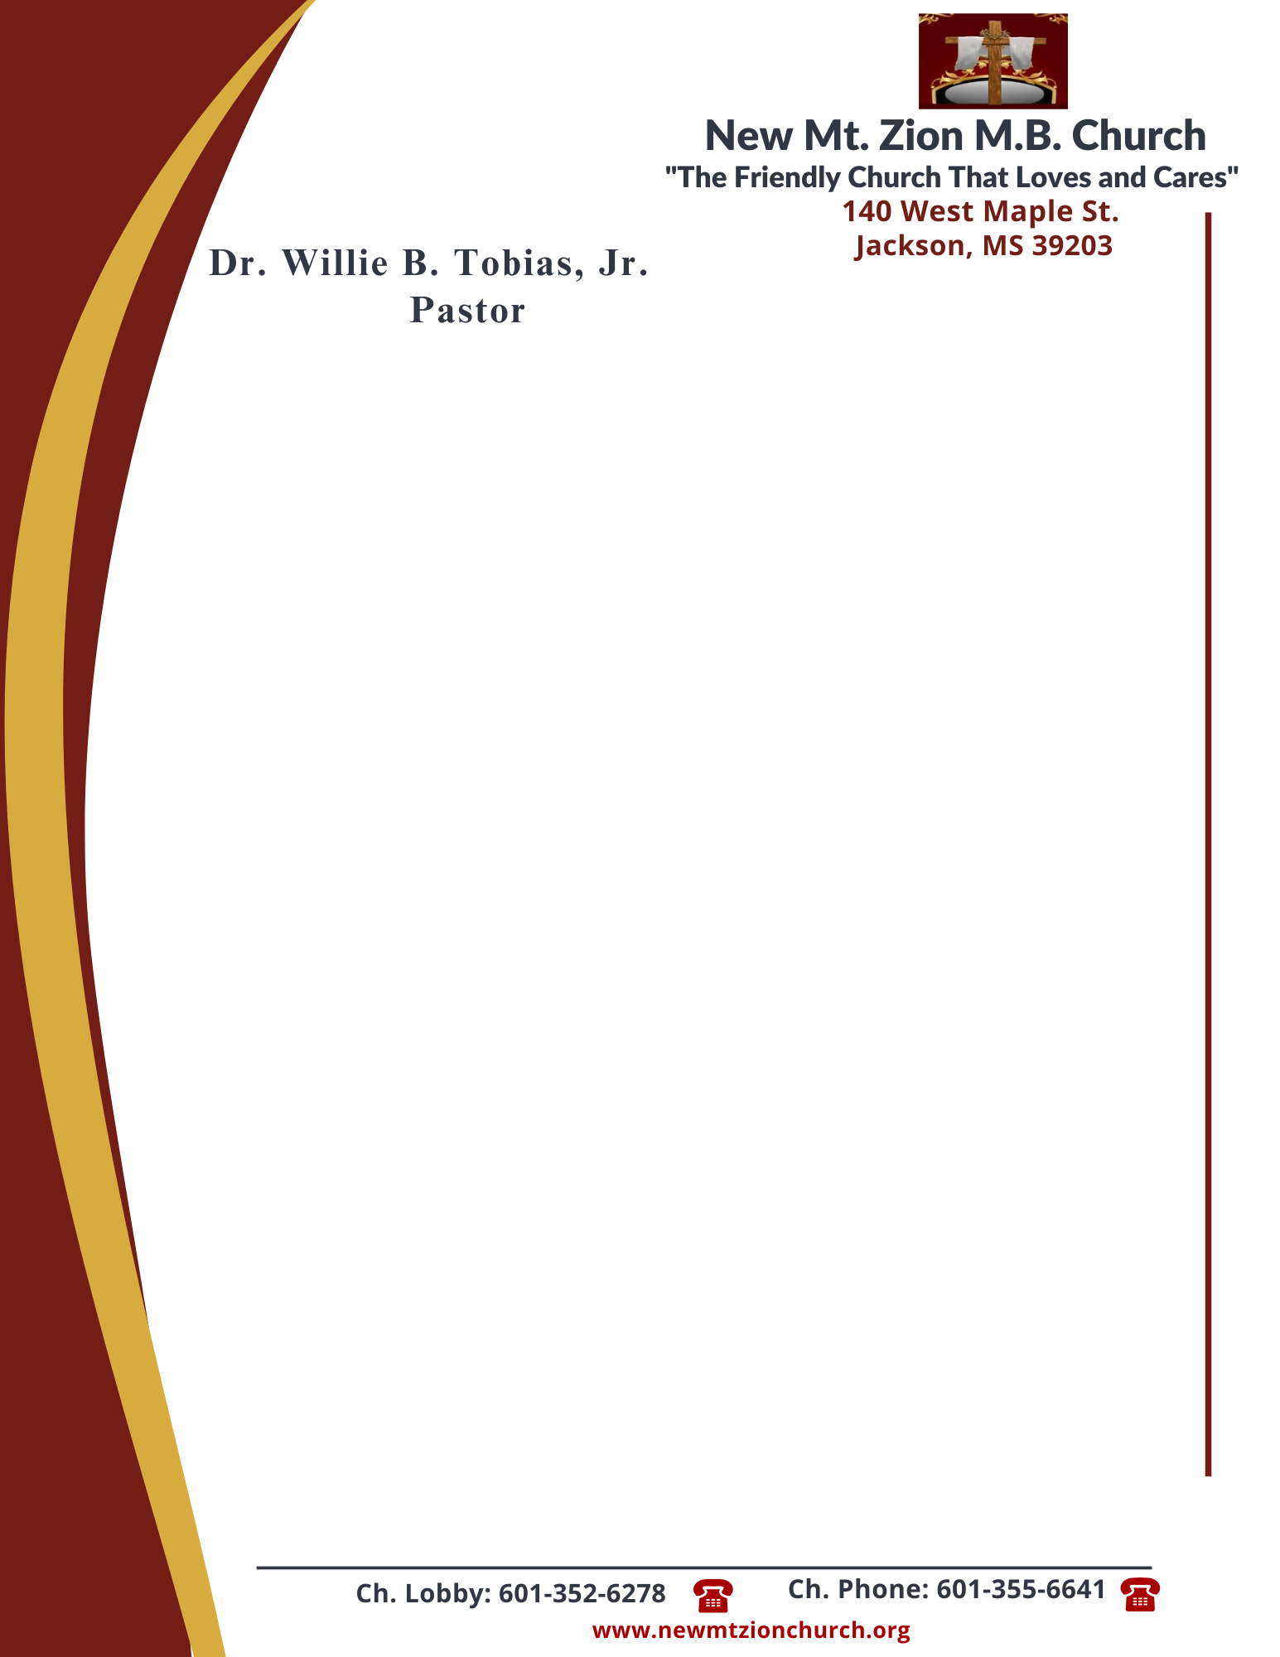

January 8, 2024

“Continuation of The Law”
Exodus 20: 1-26
The world offers various opinions. Is it left up to man to formulate his own values, his own system of morality and ethics? +

- Verse 13 says thou shall not kill. We discussed that one who commits a murder can be saved and forgiven. Can one who commits self-murder (suicide) be forgiven by GOD? Provide scripture references. (Dec. Ricardo Wilson)

- Briefly interpret verse 14. How does this commandment coincide with Matthew 5:27-28? (Rev. Venus Jones)

- Briefly interpret verse 15. List numerous ways people steal. (Sis. Charlotte Cannon)

- Briefly interpret verse 16. Can an individual lie while telling the truth? Provide scripture references. (Dr. Sonja Fuqua)

- Briefly interpret verse 17. What does it mean to covet? Briefly explain how covetousness begins in the heart. (Bro. Wilbert McCoy

