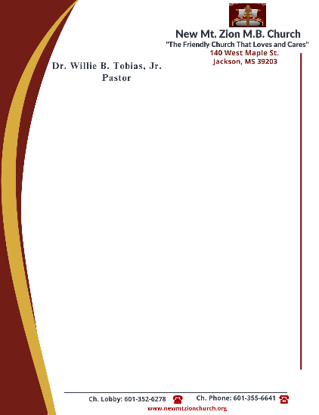

November 20, 2023

“The Law and The Promises of GOD”
Exodus Chapter 19: 1-25

Exodus Chapter 19: How was God going to get "Egypt" (the spirit of the world) out of His people? First, God had to give them His law.

- In reading verses 11-15, how does God called His people to reverence and to fear His holy presence? How does GOD demanded that the people focus totally upon Him?
(Dec. Vernell Sanders)

- In reading verses 16-25, briefly describe the manifestation of God’s presence on Mt. Sinai. In your opinion, why could GOD not be approached by the people? ( Sis Idetra Berry)

- Moses served as Israel’s mediator. Do we have or do we need a mediator today? Provide scripture references. ( Sis. Janene Wilson)

“Continuation of The Law”
Exodus 20: 1-26
The world offers various opinions. Is it left up to man to formulate his own values, his own system of morality and ethics?

- In reading verses 1-2, how do we see the existence of GOD from the beginning of time? What does the name, “The Lord” mean? ( Sis. Carolyn Miller)

- In reading verse 3, how would you define polytheism? Briefly name some things we make idol gods and we put them before the true and living GOD. ( Minister Venus Jones)

