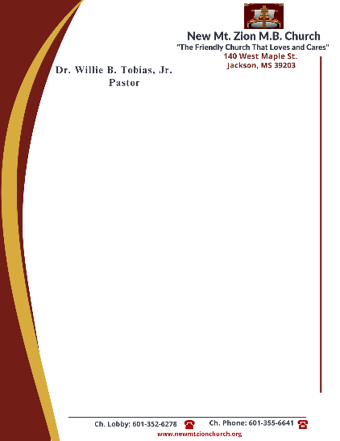

November 27, 2023

“Continuation of The Law”
Exodus 20: 1-26
The world offers various opinions. Is it left up to man to formulate his own values, his own system of morality and ethics?

- In reading verses 1-2, how do we see the existence of GOD from the beginning of time? What does the name, “The Lord” mean? (Sis. Carolyn Miller)

- In reading verse 3, how would you define polytheism? Briefly name some things we make idol gods and we put them before the true and living GOD. (Minister Venus Jones)

- In your understanding of verse 4-6, how does idolatry give a false or distorted picture of God? Briefly describe the jealousy of GOD. (Sis. Rosa Todd)

- How does one’s name reflect their nature? How do you think we are misusing GOD’S name today? (Sis. Genetra Robinson)

- Verses 8-11, gives reference to the Sabbath day. When did GOD initially create a day of rest? Why has obeying this commandment become a challenge to some? (Sis. Monica Tobias)

