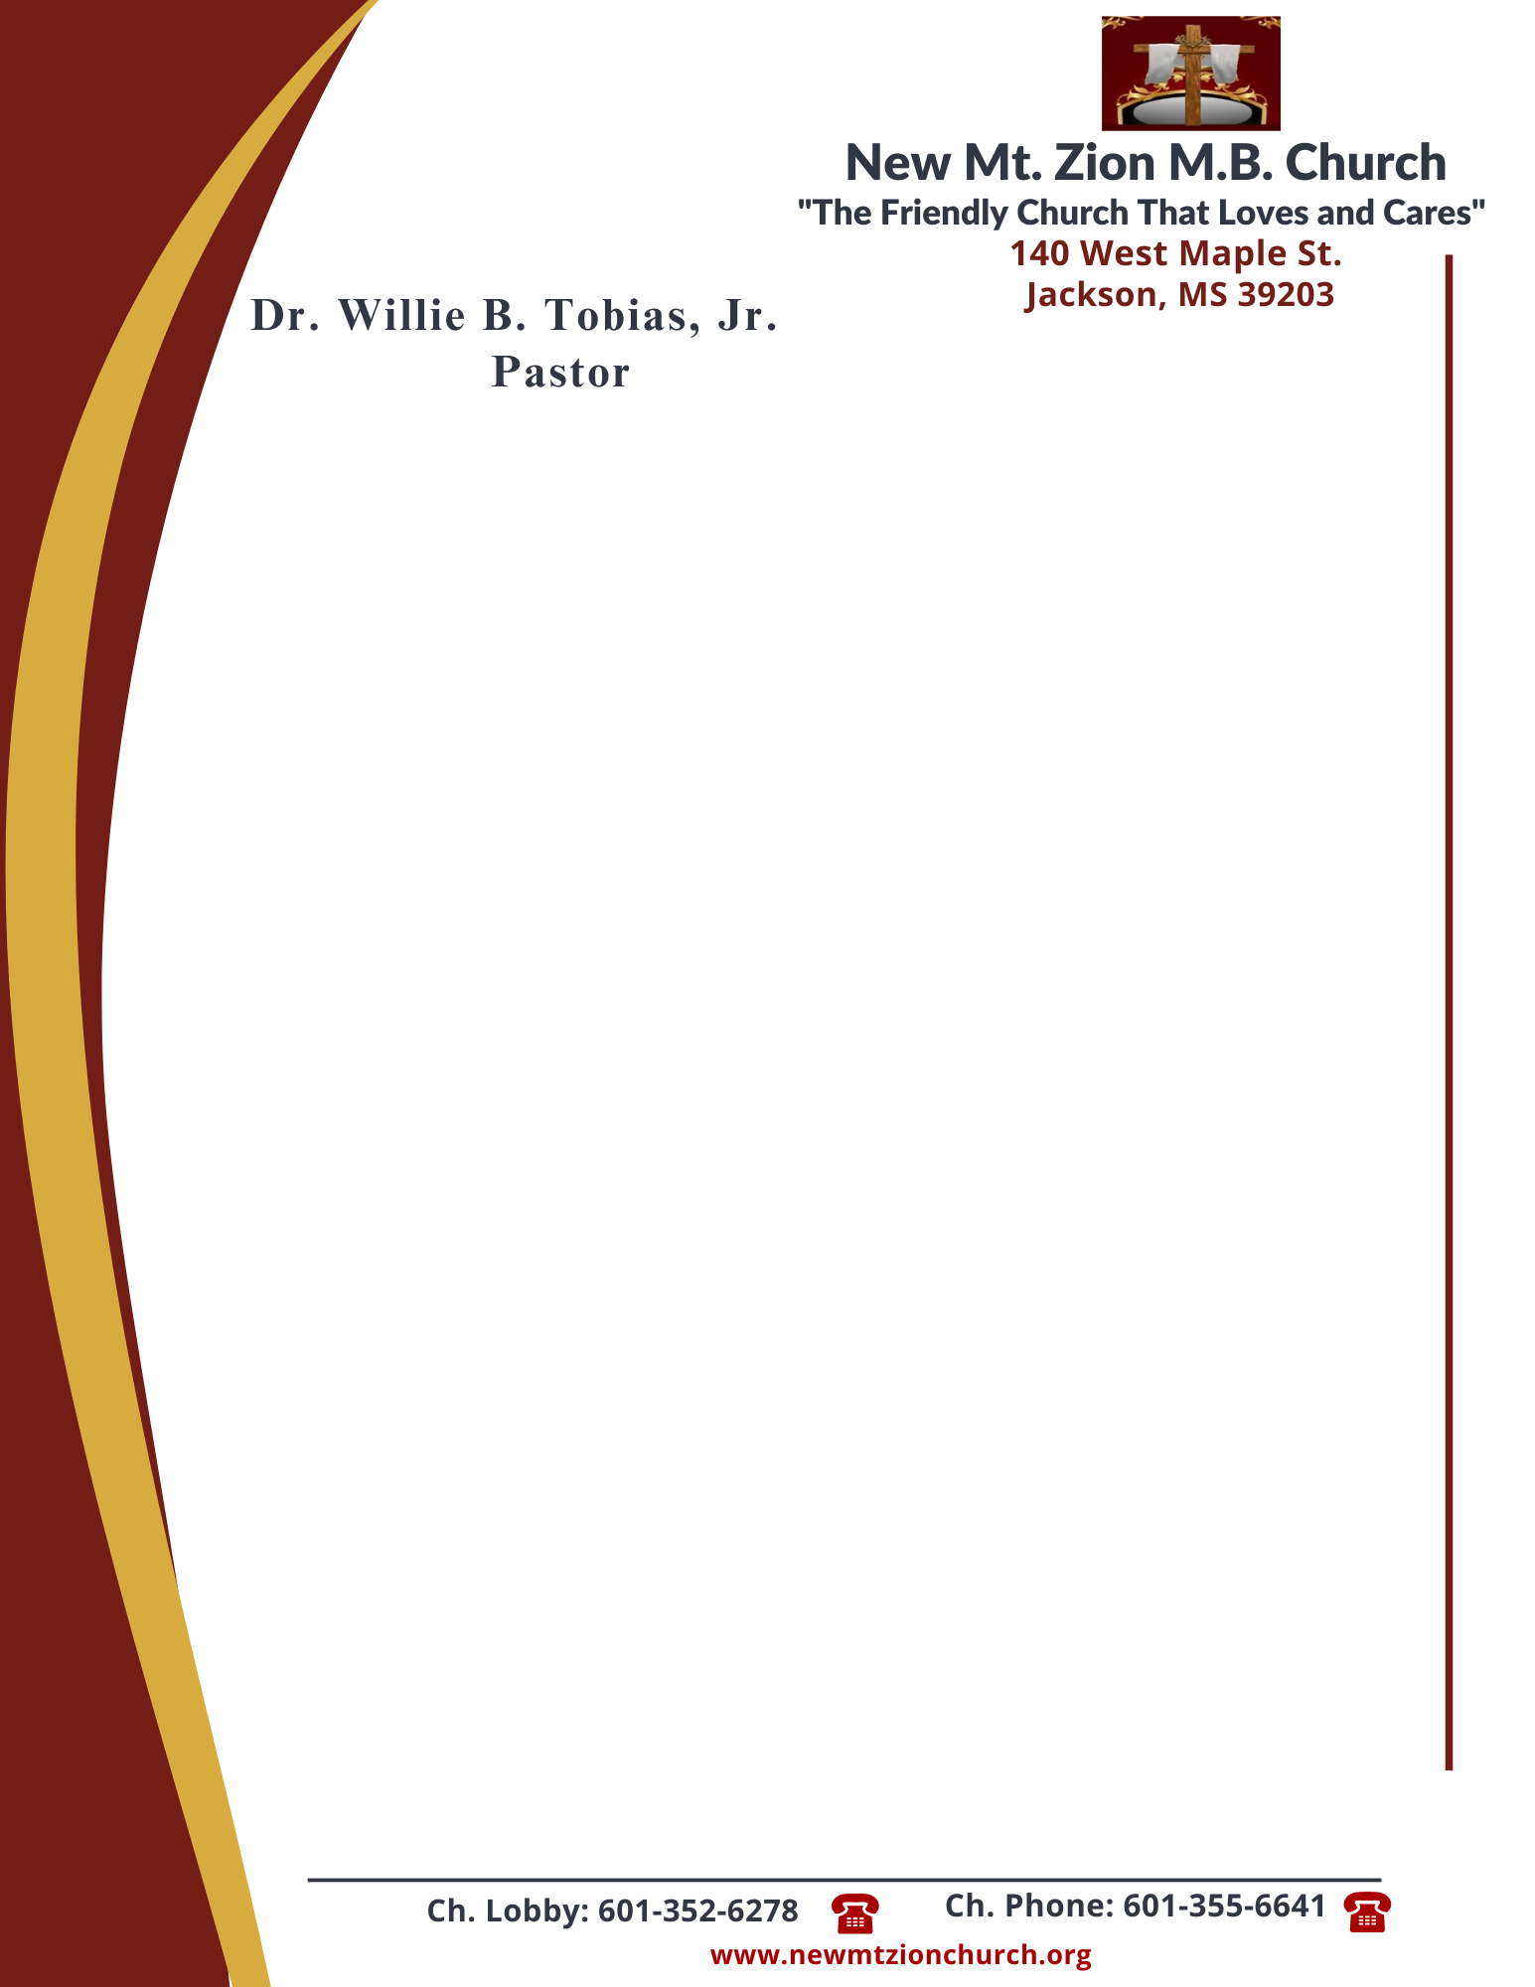

October 16, 2023
“God’s Power and Man’s Effort Working Together”
Exodus Chapter 17:1-15

Exodus Chapter 17, the Israelites needed a miracle. Under pressure to quench Israel’s thirst, Mose’s is told to strike the rock at Horeb in the same way that He struck the Nile River. Water came forth and the people were able to drink.

1. What did the people complain to Moses about? Was it reasonable to blame Moses for this? What can be learned from the way Moses responds to their complaining, verses 1-3? (Sis. Juanita Taylor)

2. What was Moses afraid the people would do and who did he cry out to? Who and what was Moses supposed to take with him to find water at the rock of Horeb? How is the rock that Moses struck like Jesus Christ, verses 4-7? (Deacon Ralph Woullard)

3. Briefly describe the sequence of events as Moses holds his arms up and the sons of Israel have victory over Amalek. What three elements were needed for the Israelites to win this battle? What was Gods purpose in this, verses 8-13? (Dr. Hymethia Thompson)

4. What did the Lord want recorded about this battle and why? What does it mean for the Israelites to have the Lord as their banner, verses 14-15? (Sis. Brenda Newson)

