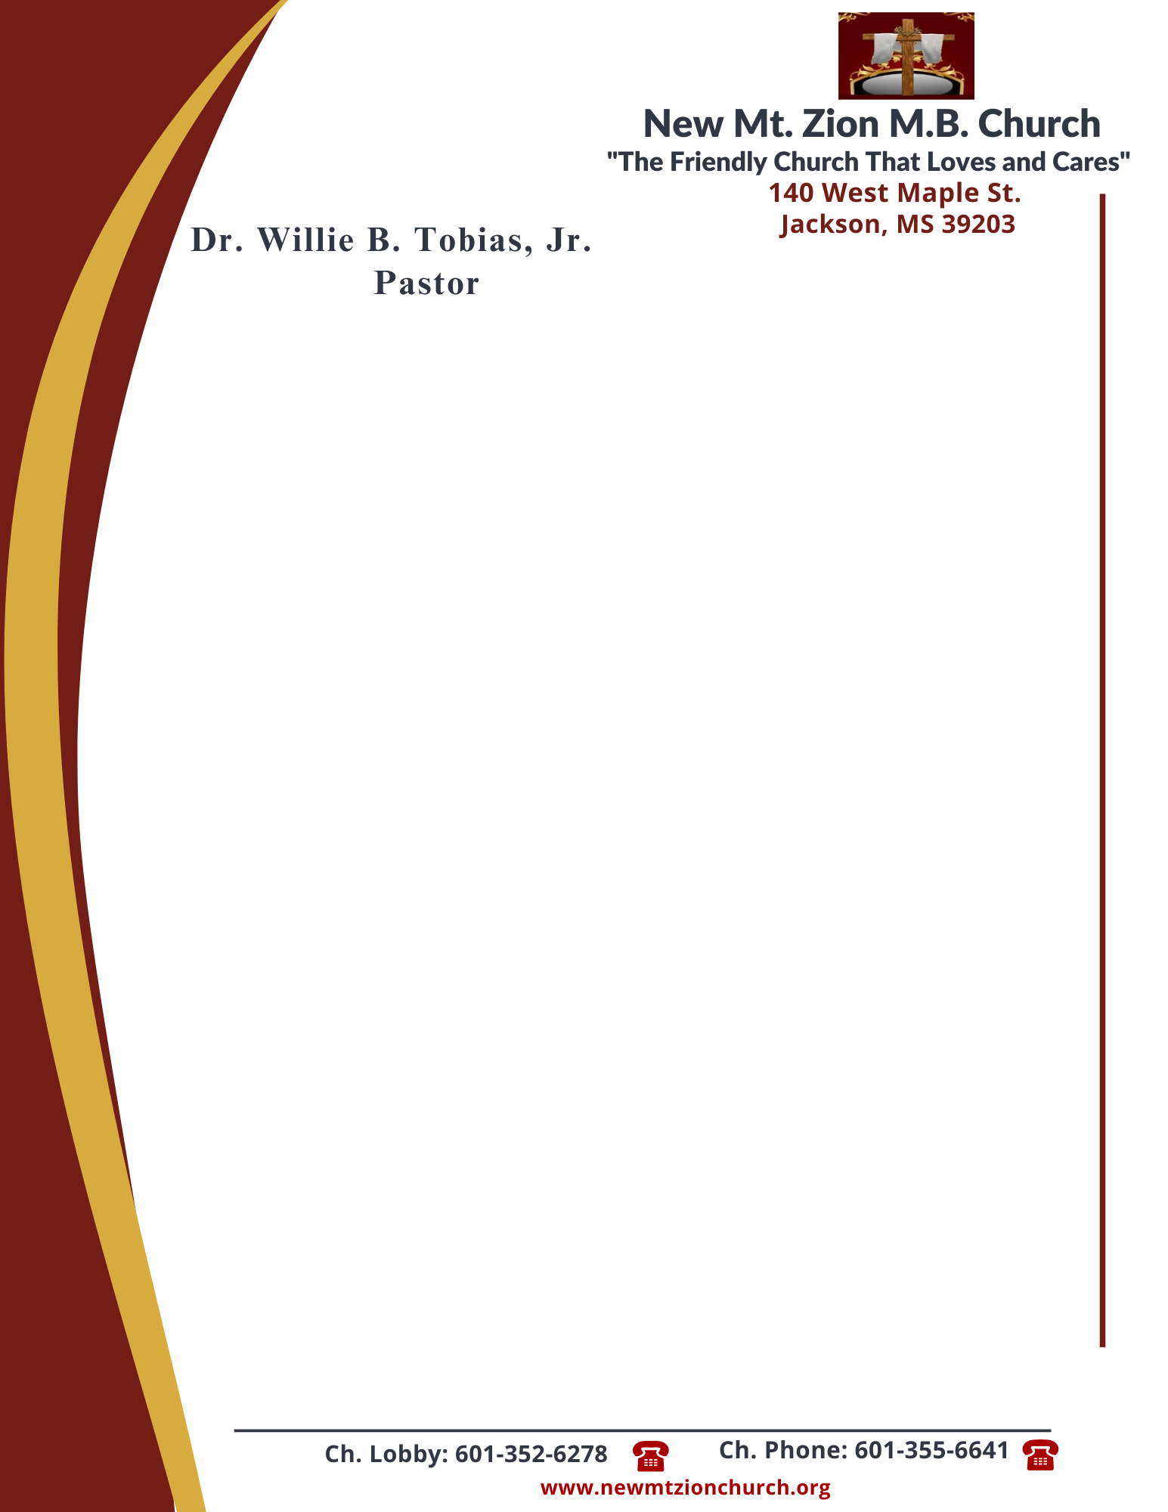

October 2, 2023
“God’s Promise to Provide”
Exodus Chapter 16:8-30

Exodus Chapter 16, following the Israelites deliverance from bondage, Moses led he chldren of Israel to Mount Sinai. While on the journey, the Israelites murmured because of the lack of food. The Lord blessed the children of Israel with manna and instructed them to gather it every morning except on the Sabbath.

1. Why was Moses not really the target even if they spoke out against Moses? Who is all the grumbling against? What lesson did God want to teach them as he provided the manna to them, verses 8-12? (Bro. Wilbert McCoy)
2. Where did the manna come from? Why is it referred to as the bread from heaven, verses 13-15? ( Sis. Deborah Newson)
3. What rules were given for collecting the manna? Why were these rules given? Why did some of them not listen to Moses and save some until morning, verese 16-21? (Dec. Ricardo Wilson)
4. Why do you think God provided for the Israelites in the way He did with daily manna and why did it not become foul? What spiritual lessons can we learn from the Lord’s instructions about manna, verses 22-26? (Bro. Malcolm Dodd)
5. Why did God force the people to rest on the Sabbath? Why did some people still go out to gather on the Sabbath day? What principles about poeople’s nature can we learn from this, verses 27-30? (Dec. James Todd)

