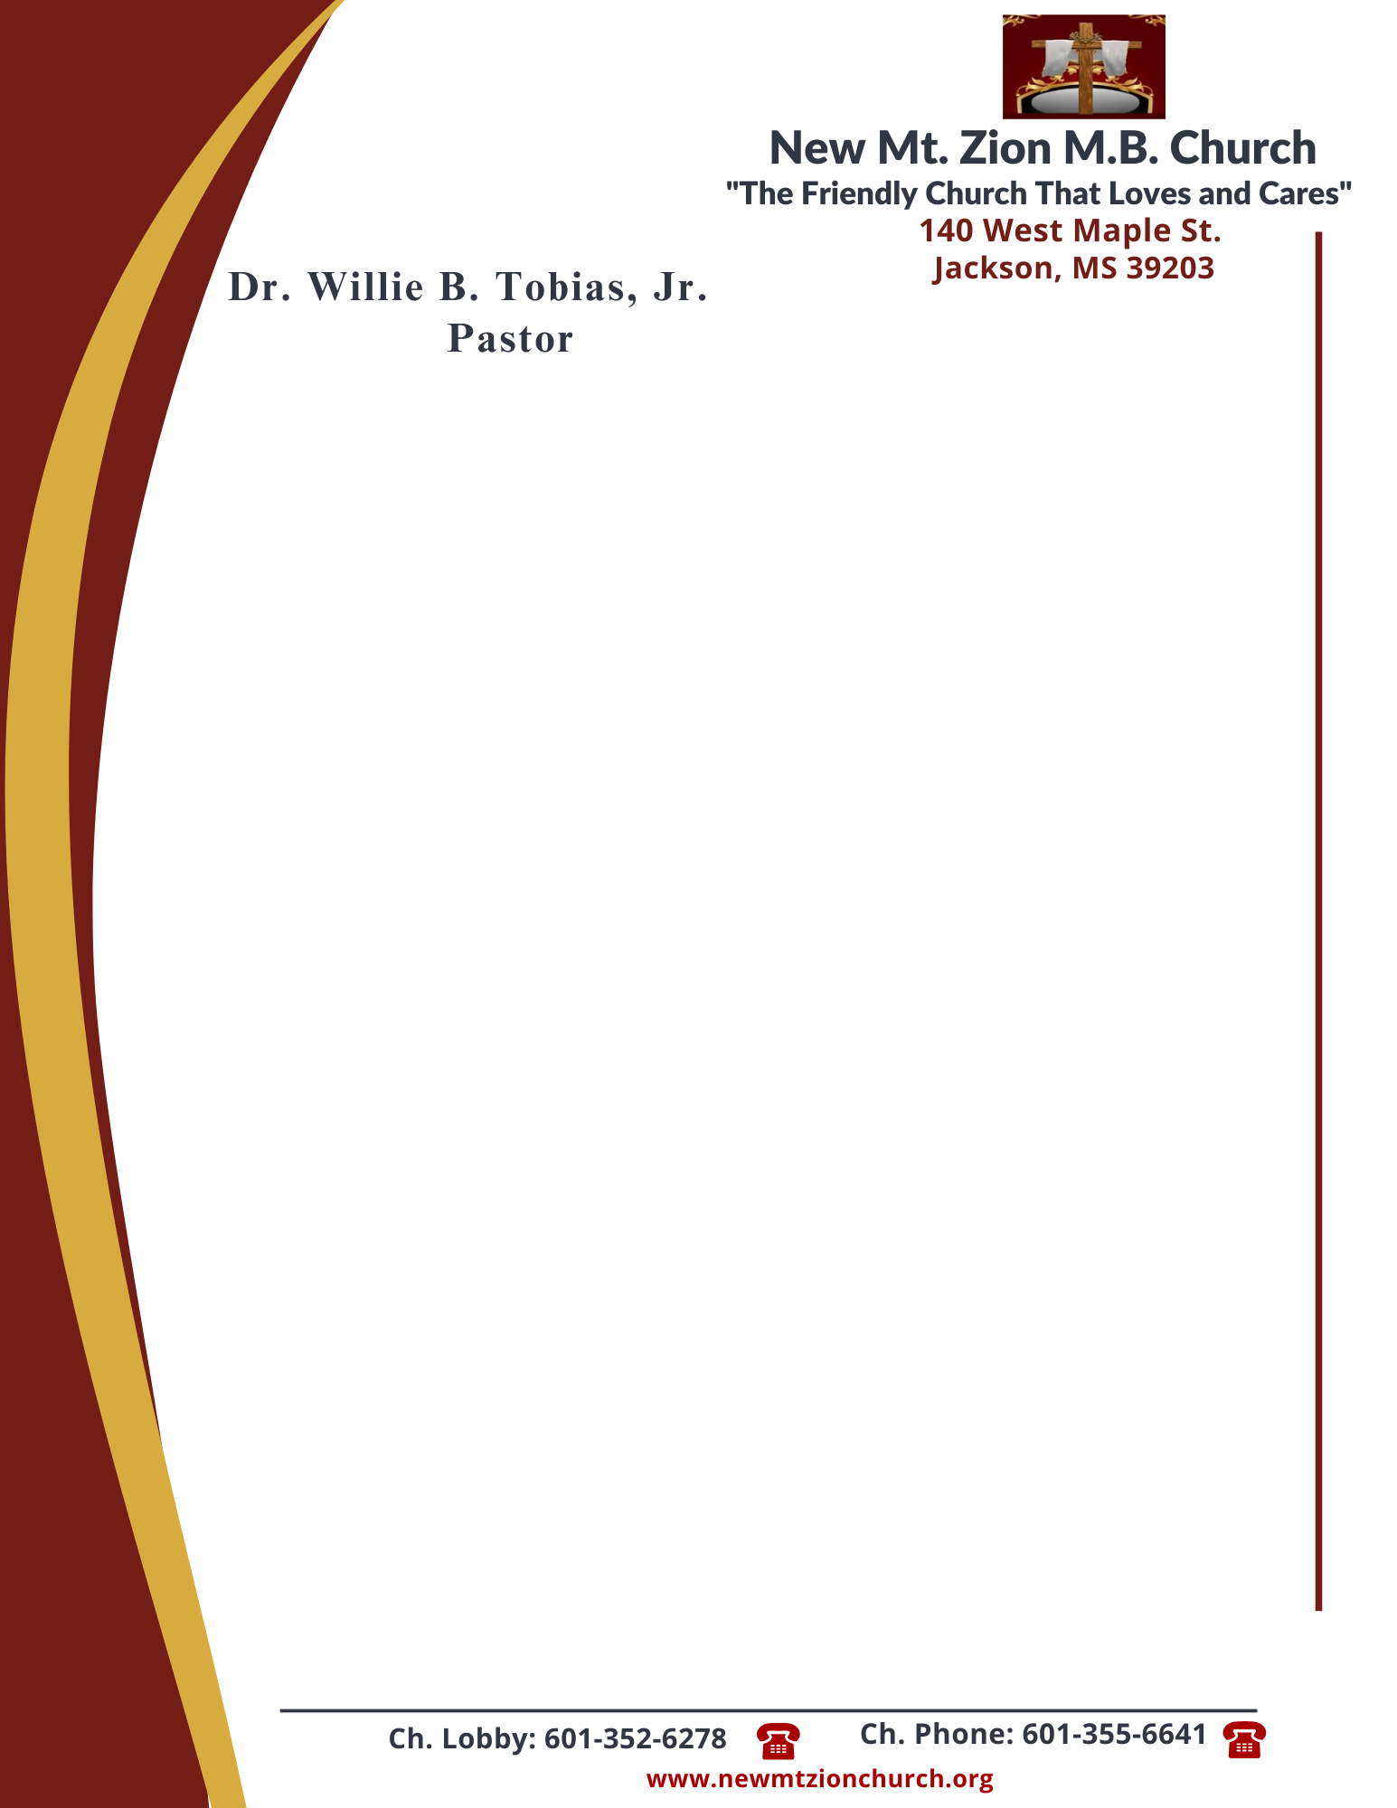

October 9, 2023
“God’s Promise to Provide”
Exodus Chapter 16:16-36

Exodus Chapter 16, following the Israelites deliverance from bondage, Moses led he chldren of Israel to Mount Sinai. While on the journey, the Israelites murmured because of the lack of food. The Lord blessed the children of Israel with manna and instructed them to gather it every morning except on the Sabbath.

1. What rules were given for collecting the manna? Why were these rules given? Why did some of them not listen to Moses and save some until morning, verese 16-21? (Dec. Ricardo Wilson)
2. Why do you think God provided for the Israelites in the way He did with daily manna and why did it not become foul? What spiritual lessons can we learn from the Lord’s instructions about manna, verses 22-26? (Bro. Malcolm Dodd)
3. Why did God force the people to rest on the Sabbath? Why did some people still go out to gather on the Sabbath day? What principles about poeople’s nature can we learn from this, verses 27-30? (Dec. James Todd)
4. What commandment does the Lord give His people? Why was this commandment given, verses 31-34? (Sis. Idetra Berry)
5.How long did the children of Israel eat the manna? Why? How does this passage challenge your understanding of God’s provision and timing, verses 35-36? (Sis. Peggy Jennings)

