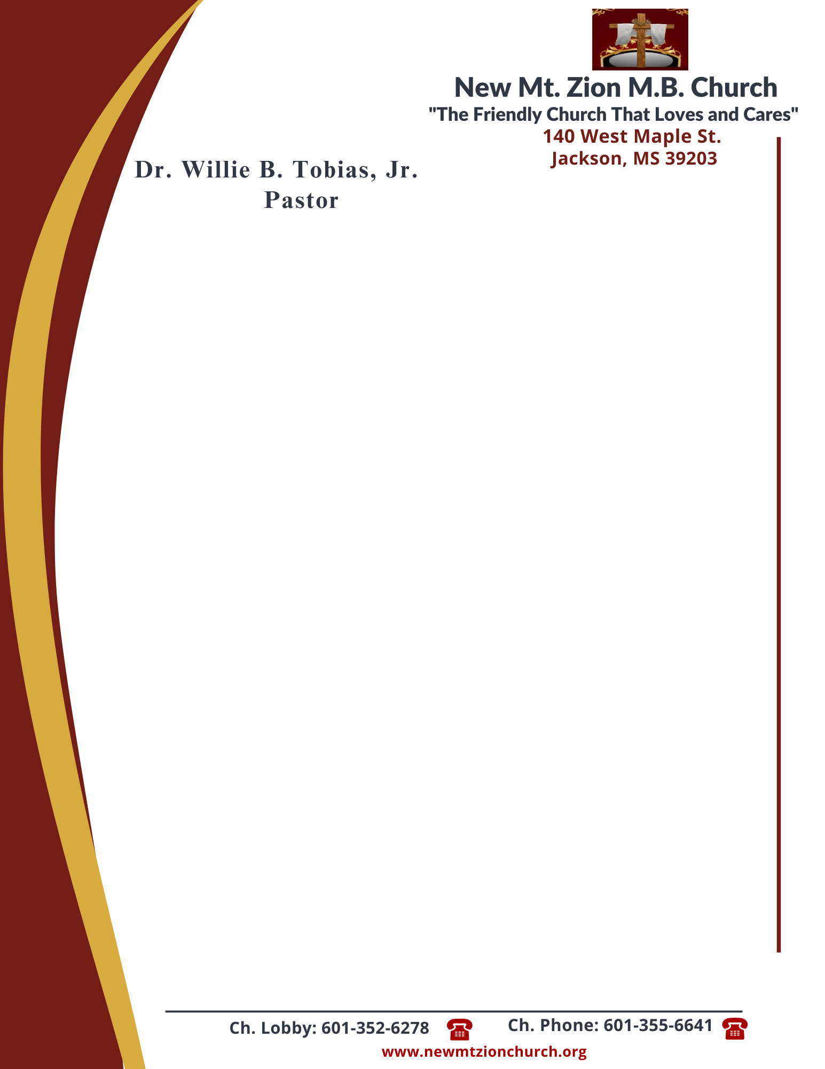

September 25, 2023
“God’s Promise to Provide”
Exodus Chapter 16:1-21

Exodus Chapter 16, following the Israelites deliverance from bondage, Moses led he chldren of Israel to Mount Sinai. While on the journey, the Israelites murmured because of the lack of food. The Lord blessed the children of Israel with manna and instructed them to gather it every morning except on the Sabbath.

1. How would you describe the attitude of the people? Why do you think they are forgetting again the miracles God has done for them? What does this tell us about the nature of sin, verses 1-3? (Dec. Sylvester Ford)
2. In verses 4-5, what specific instructions did the Lord give the people about gathering this bread from heaven? In what ways might the gathering of only a limited amount of bread each day have been a test for the children of Israel? Why does the Lord give us commandments? (Sis. Charlotte Cannon)
3. In verses 6-8, what does the Israelites complaining tell us about their relationship with Moses and Aaron? What is Moses and Aarons response to the Israelites’ complaints? What is God’s response to the Israelites? (Dec. Vernell Fleming)
4. Why was Moses not really the target even if they spoke out against Moses? Who is all the grumbling against? What lesson did God want to teach them as he provided the manna to them, verses 8-12? (Bro. Wilbert McCoy)
5. Where did the manna come from? Why is it referred to as the bread from heaven, verses 13-15? ( Sis. Deborah Newson)
6. What rules were given for collecting the manna? Why were these rules given? Why did some of them not listen to Moses and save some until morning, verese 16-21? (Dec. Ricardo Wilson)

