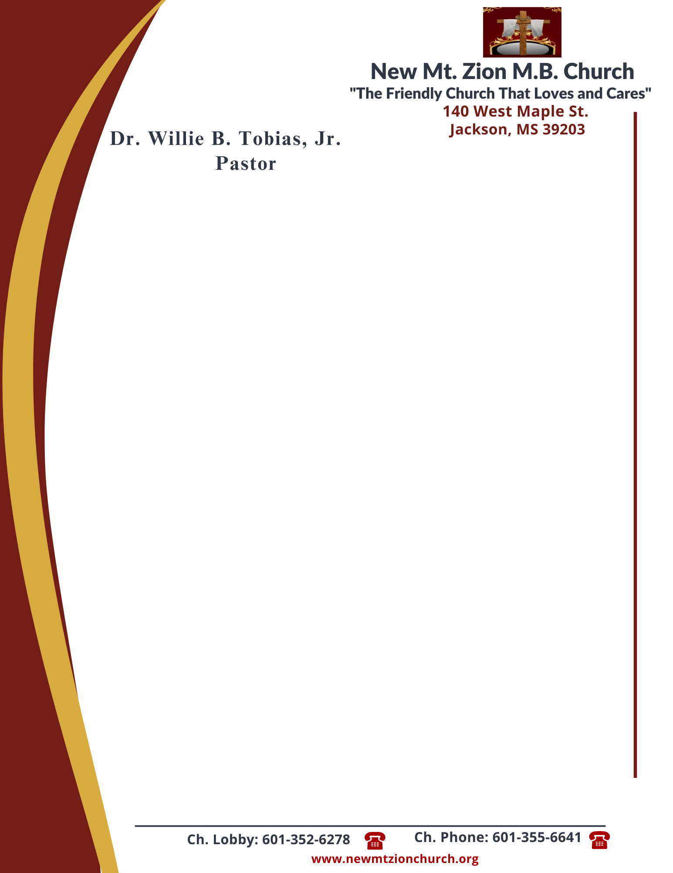

August 7, 2023

“Acting on Faith in God’s Word”

Exodus Chapter 14:5-20

Exodus Chapter 14, tells how Pharaoh changed his mind about letting the people of Israel to leave Egypt. As the Hebrews were leaving the land, he ordered his men to bring the Hebrew people back. Moses and the people stood stranded between the Egyptian guards and the unforgivig Red Sea.

1. Describe Pharaoh and his officials attitudes. Why do you think they didn’t seem to care about all the plagues that had come on them, verses 5-9? (Deacon James Todd)

2. In verses 10-12, how did the Israelites feel when they saw the Egyptians? How would you describe their faith? For what reason do you think God had for bringing the Egyptian army there? (Deacon Sammie Wilson)

3. How did Moses know that God would fight for them and they would never see the Egyptians again, verses 13-14? What does this show us about Moses’ faith? (Sis. Lillie Studaway)

4. What did the Lord command Moses to tell the Israelite people and what was Moses told to do regarding the Red Sea, verses 15-18? Why do you think God led the people away from the Land of the Philistines and toward the Red Sea? (Sis. Charlotte Cannon)

5. After reading verses 19-20, who is the Angel of God? What miracle does God perform that night and what happens to Pharaoh’s army? (Sis. Veronica Mance)

