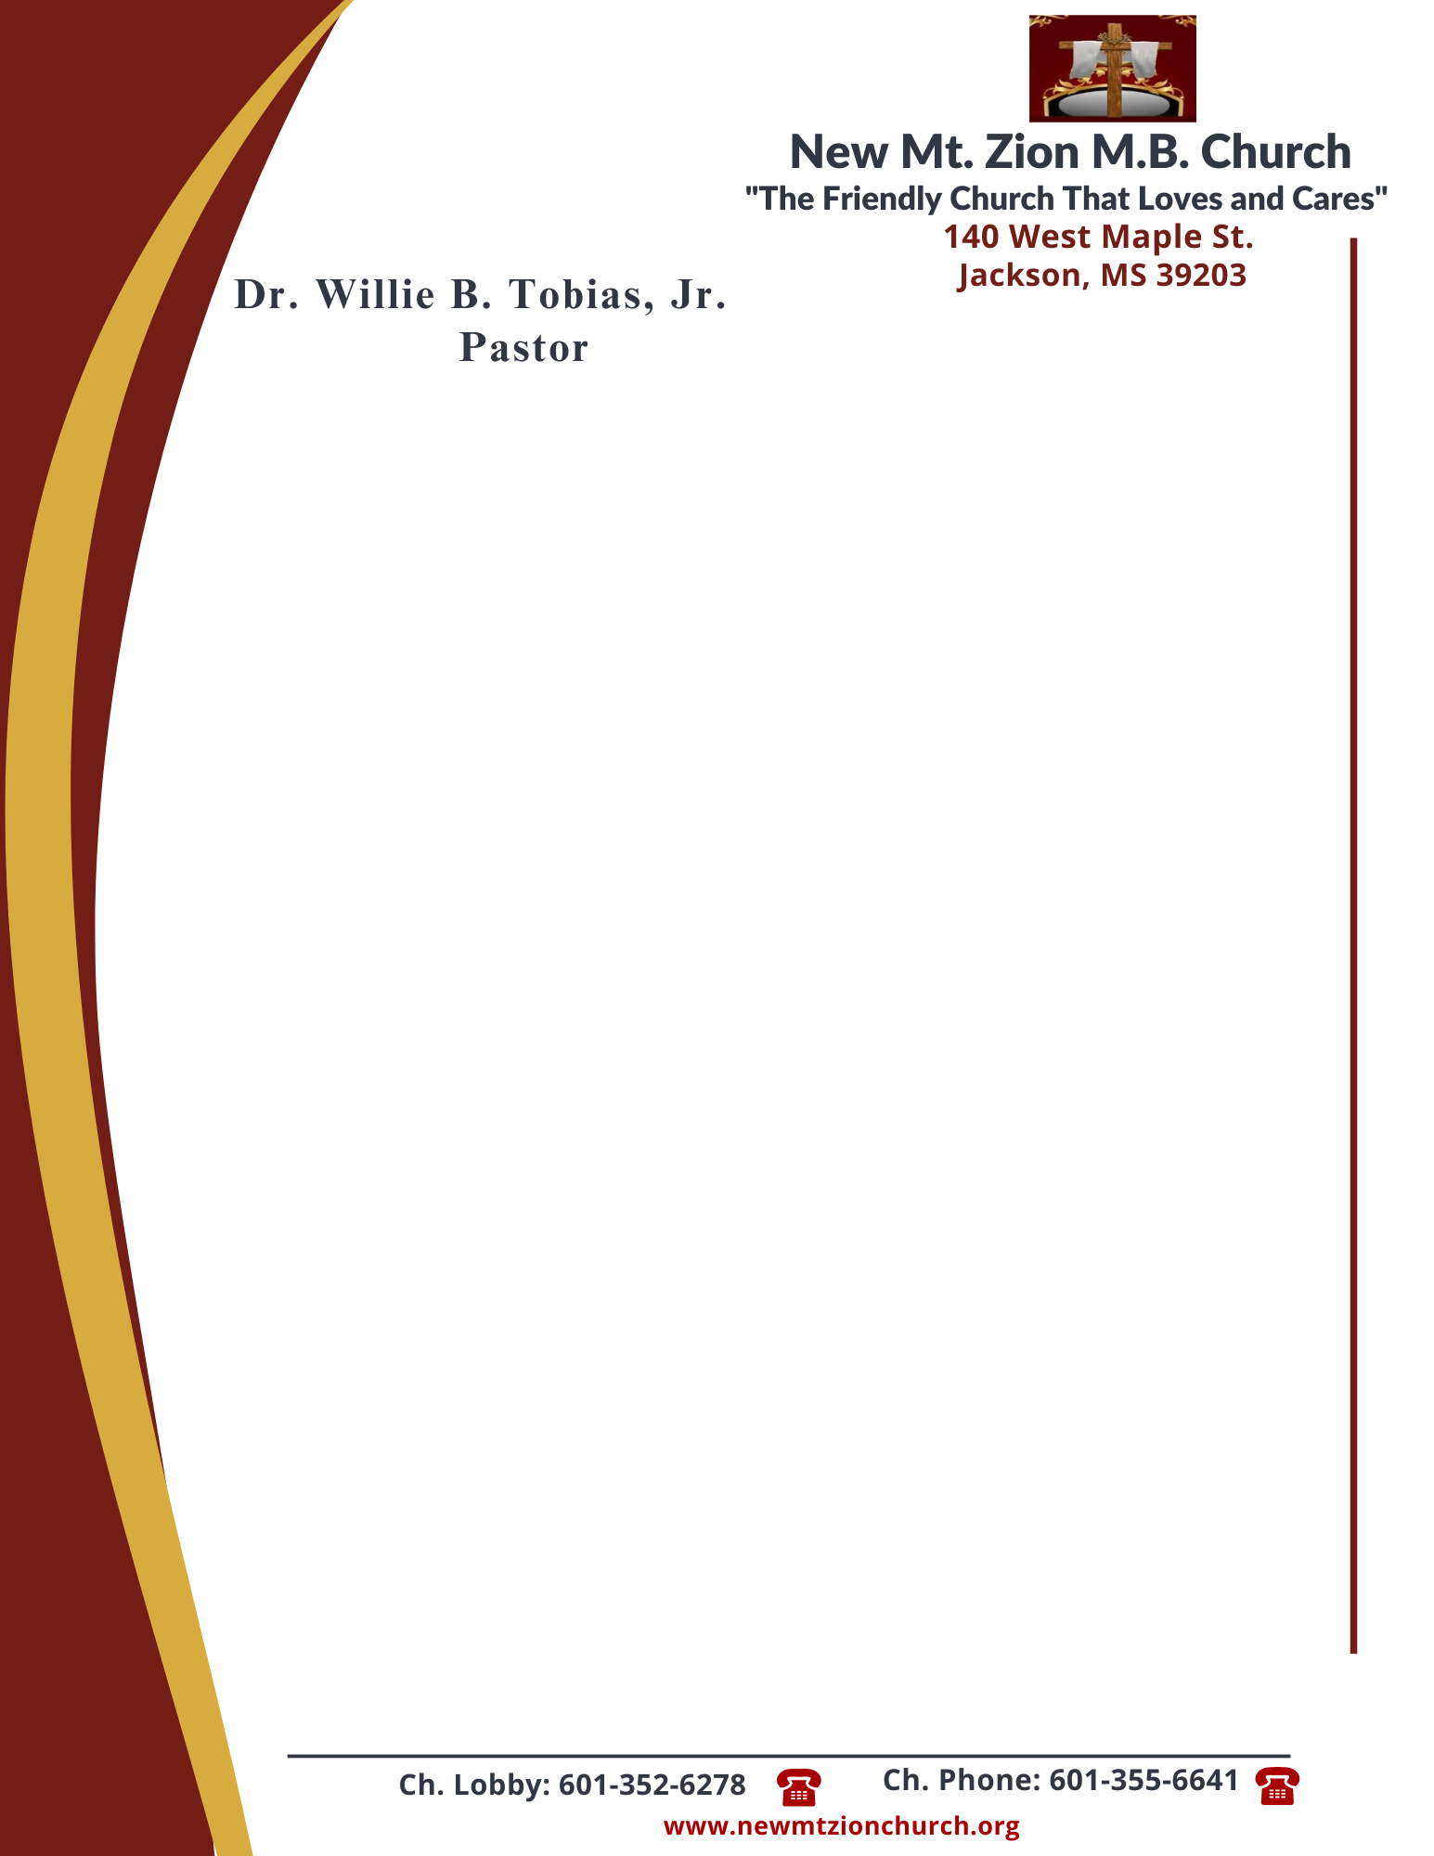

August 14, 2023

“Acting on Faith in God’s Word”

Exodus Chapter 14:15-31

Exodus Chapter 14, tells how Pharaoh changed his mind about letting the people of Israel to leave Egypt. As the Hebrews were leaving the land, he ordered his men to bring the Hebrew people back. Moses and the people stood stranded between the Egyptian guards and the unforgivig Red Sea.

1. What did the Lord command Moses to tell the Israelite people and what was Moses told to do regarding the Red Sea, verses 15-18? Why do you think God led the people away from the Land of the Philistines and toward the Red Sea? (Sis. Charlotte Cannon)

2. After reading verses 19-20, who is the Angel of God? What miracle does God perform that night and what happens to Pharaoh’s army? (Sis. Veronica Mance)

3. What did God do to allow the Israelites to part the Red Sea, verses 21-22? How does this example teach us to exercise faith in the Lord today? (Sis. Deborah Steverson)

4. What happened to the Egyptians when they followed Israel through the sea? What does God do, verses 23-28? (Bro. Christopher Chapman)

5. How does Moses describe the Israelites’ final experience? What effect did this great salvation have on Israel, verses 29-31? (Sis. Leslie Jennings)

