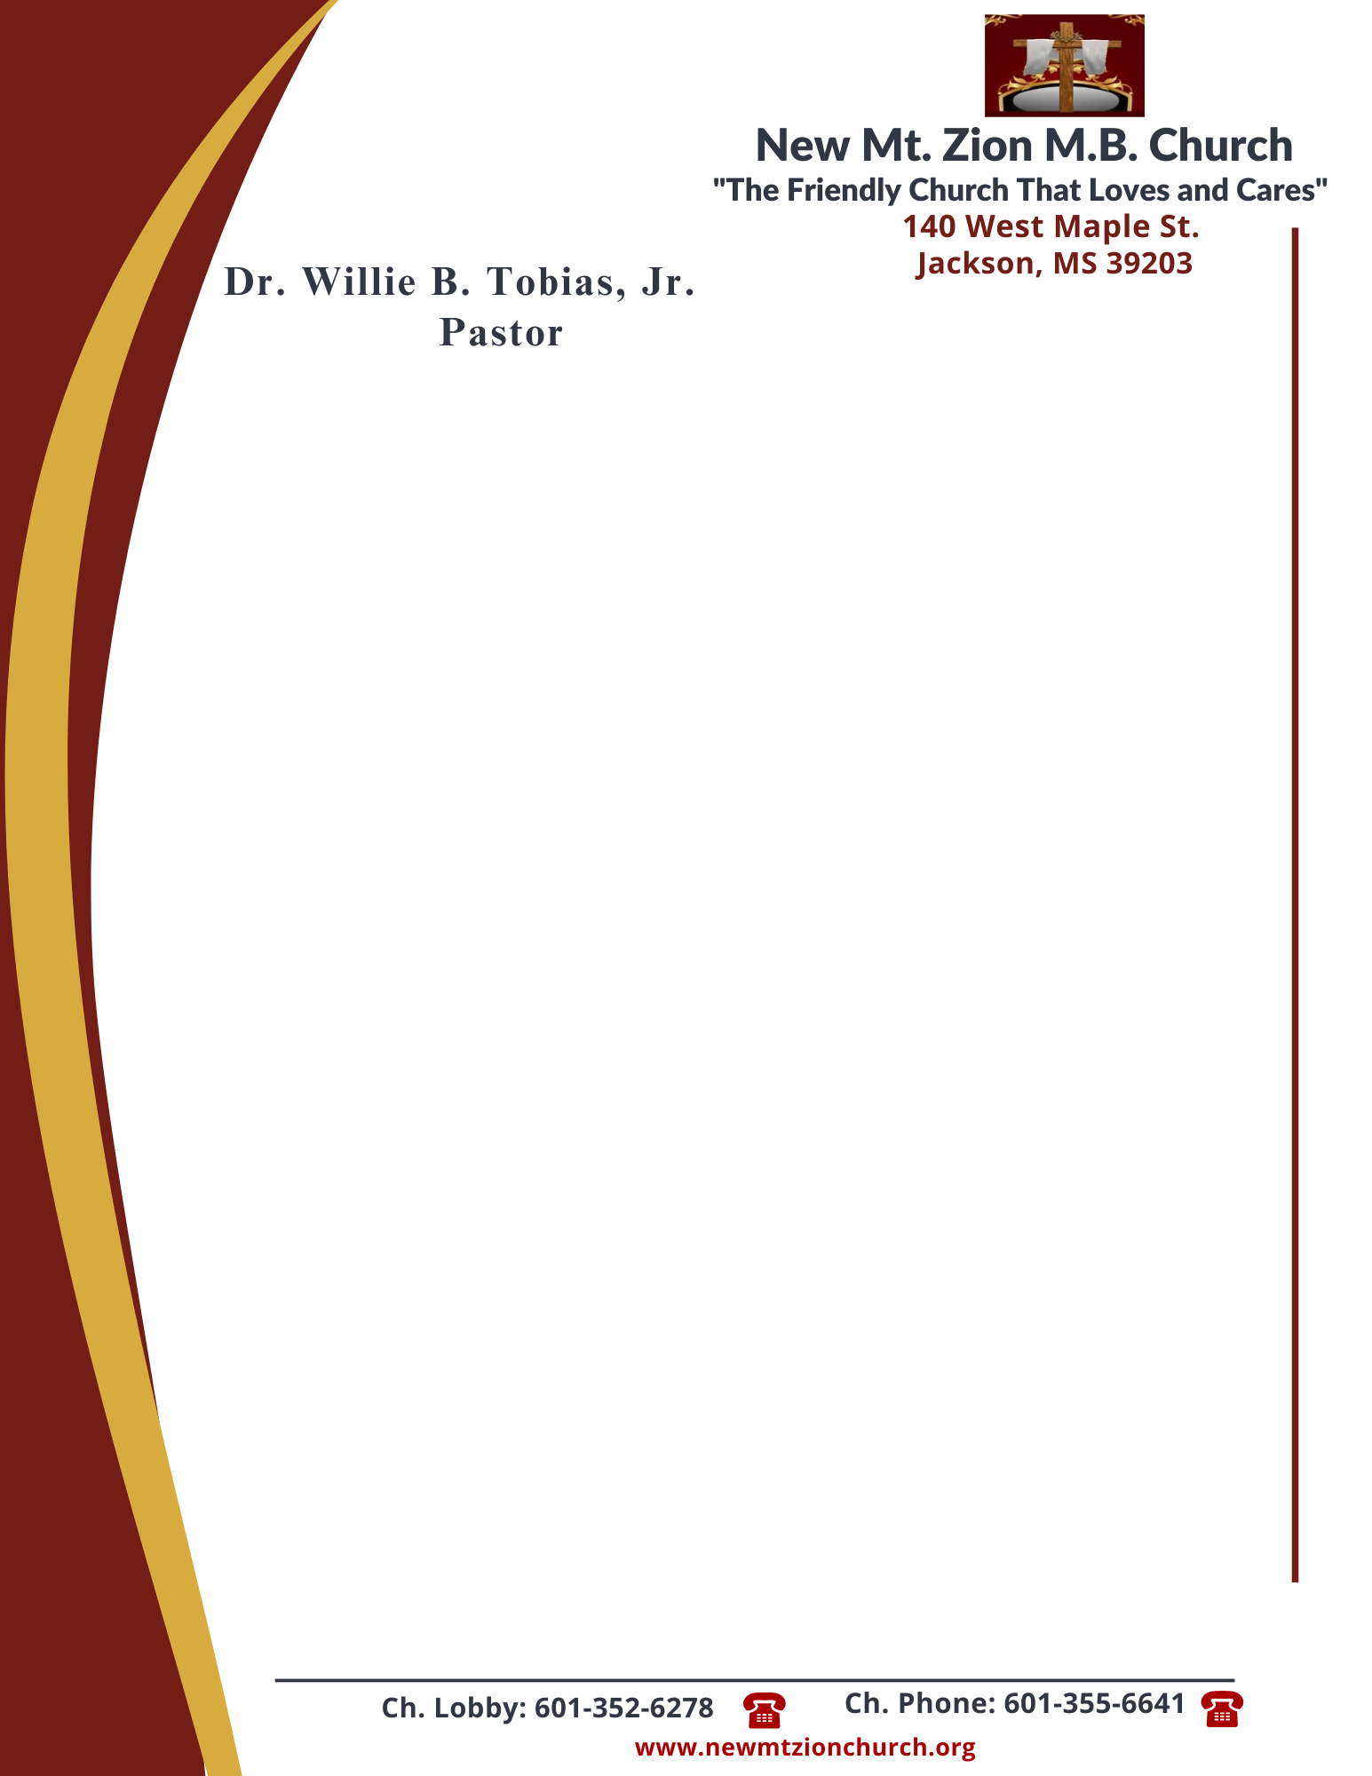

July 24, 2023
“Acting on Faith in God’s Word”
Exodus Chapter 13: 3-22

Exodus Chapter 13, describes God’s instruction to Israel for a new nation, and the nations journey out of Egypt.

1. In reading verses 3-10, what instructions were to be followed during the dedication of the first born (Sis. Idetra Berry)

2. What are the Lords instructions in verses 11-16? Why does He command this? (Sis. Doris Powell)

3. After reading verses 17-18, in what unexpected way were the people led out of Egypt? Who was responsible for the route they took? (Dec. Esther McCoy)

4. In verse 19, discuss the fullfilled promise to Joseph. Why did Moses take the bones of Joseph with him? (Sis. Carolyn Fleming)

5. By what visible means did the Lord lead His people during the Exodus, verses 20-22? As a parent with curious children, how would you explain the Passover celebration and it’s purpose? Why is it vital to teach these truths to the generation of today? (Dec. James Spiva)

