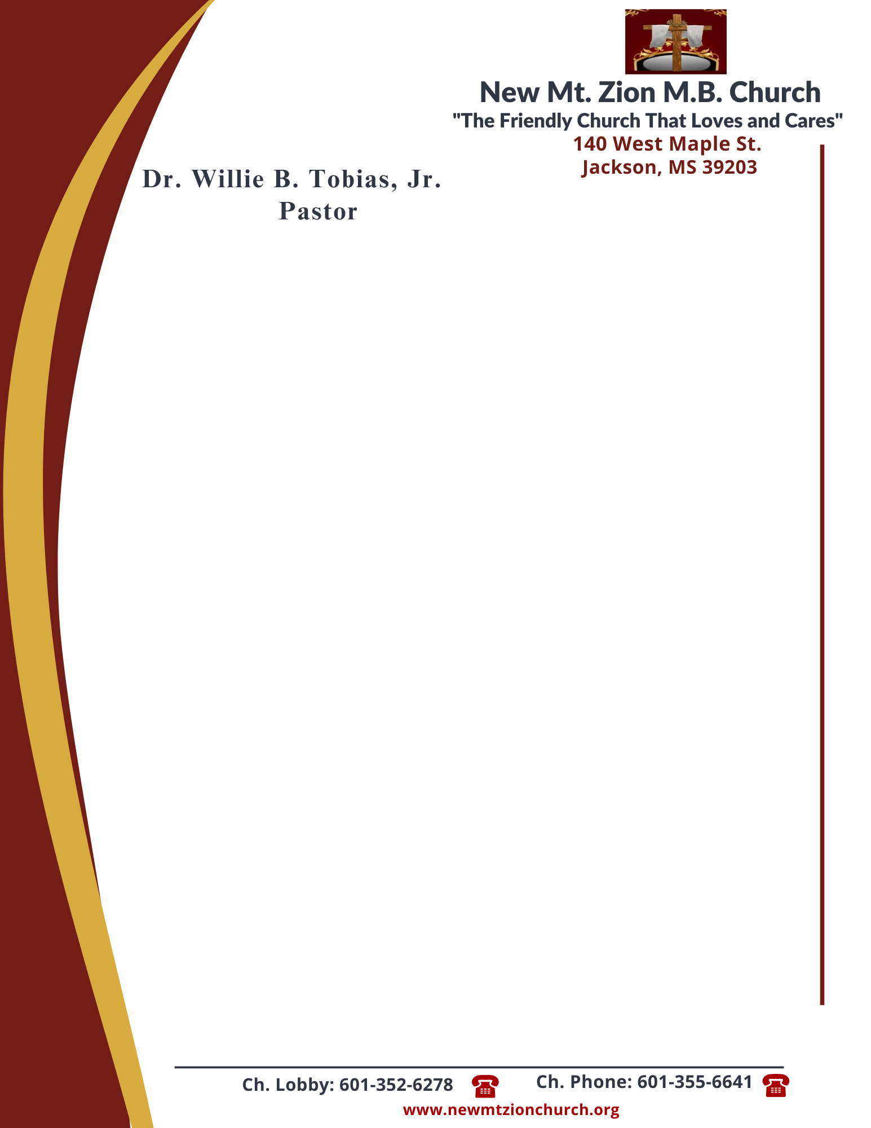

July 3, 2023
“Acting on Faith in God’s Word”
Exodus Chapter 12:33-44

Exodus Chapter 12, the Lord explained the feast of unleavened bread, or Passover, which would become a memorial to the Lord’s deliverance of Israel from bondage in Egypt. The ordinance of the Passover would help the Israelites look forward to the Messiah’s coming and the deliverance of God’s children from spiritual death.

1. In reading verse 33-34, what was the Egyptians attitude toward the command of Pharaoh to leave? What did the Israelites do when the people asked them to leave the land? What did they pack and why didn’t they put leaven in the dough? (Bro. Malcolm Dodd)

2. Why did the Egyptians think and act favorably towards the Israelites? Why do the Egyptians give so much of their material possessions to the Israelites as they leave, verses 36-37? (Sis. Marion Henderson)

3. In verses 38-39, who went with them and what is meant by a mixed multitude? Why did they eat unleavened bread while getting out of Egypt? (Dec. Vernell Fleming)

4. How long were the Israelites in Egypt? What kind of night was that last night? Who was doing the watching and why? What was the response of the people, verses 40-42? (Dr. Sonja Fuqua)

5. What instructions were given about the Passover celebration? Who shall eat of the Passover?
When can a slave eat the Passover? What about women, verses 43-44? (Sis. Sonji Cooper)

