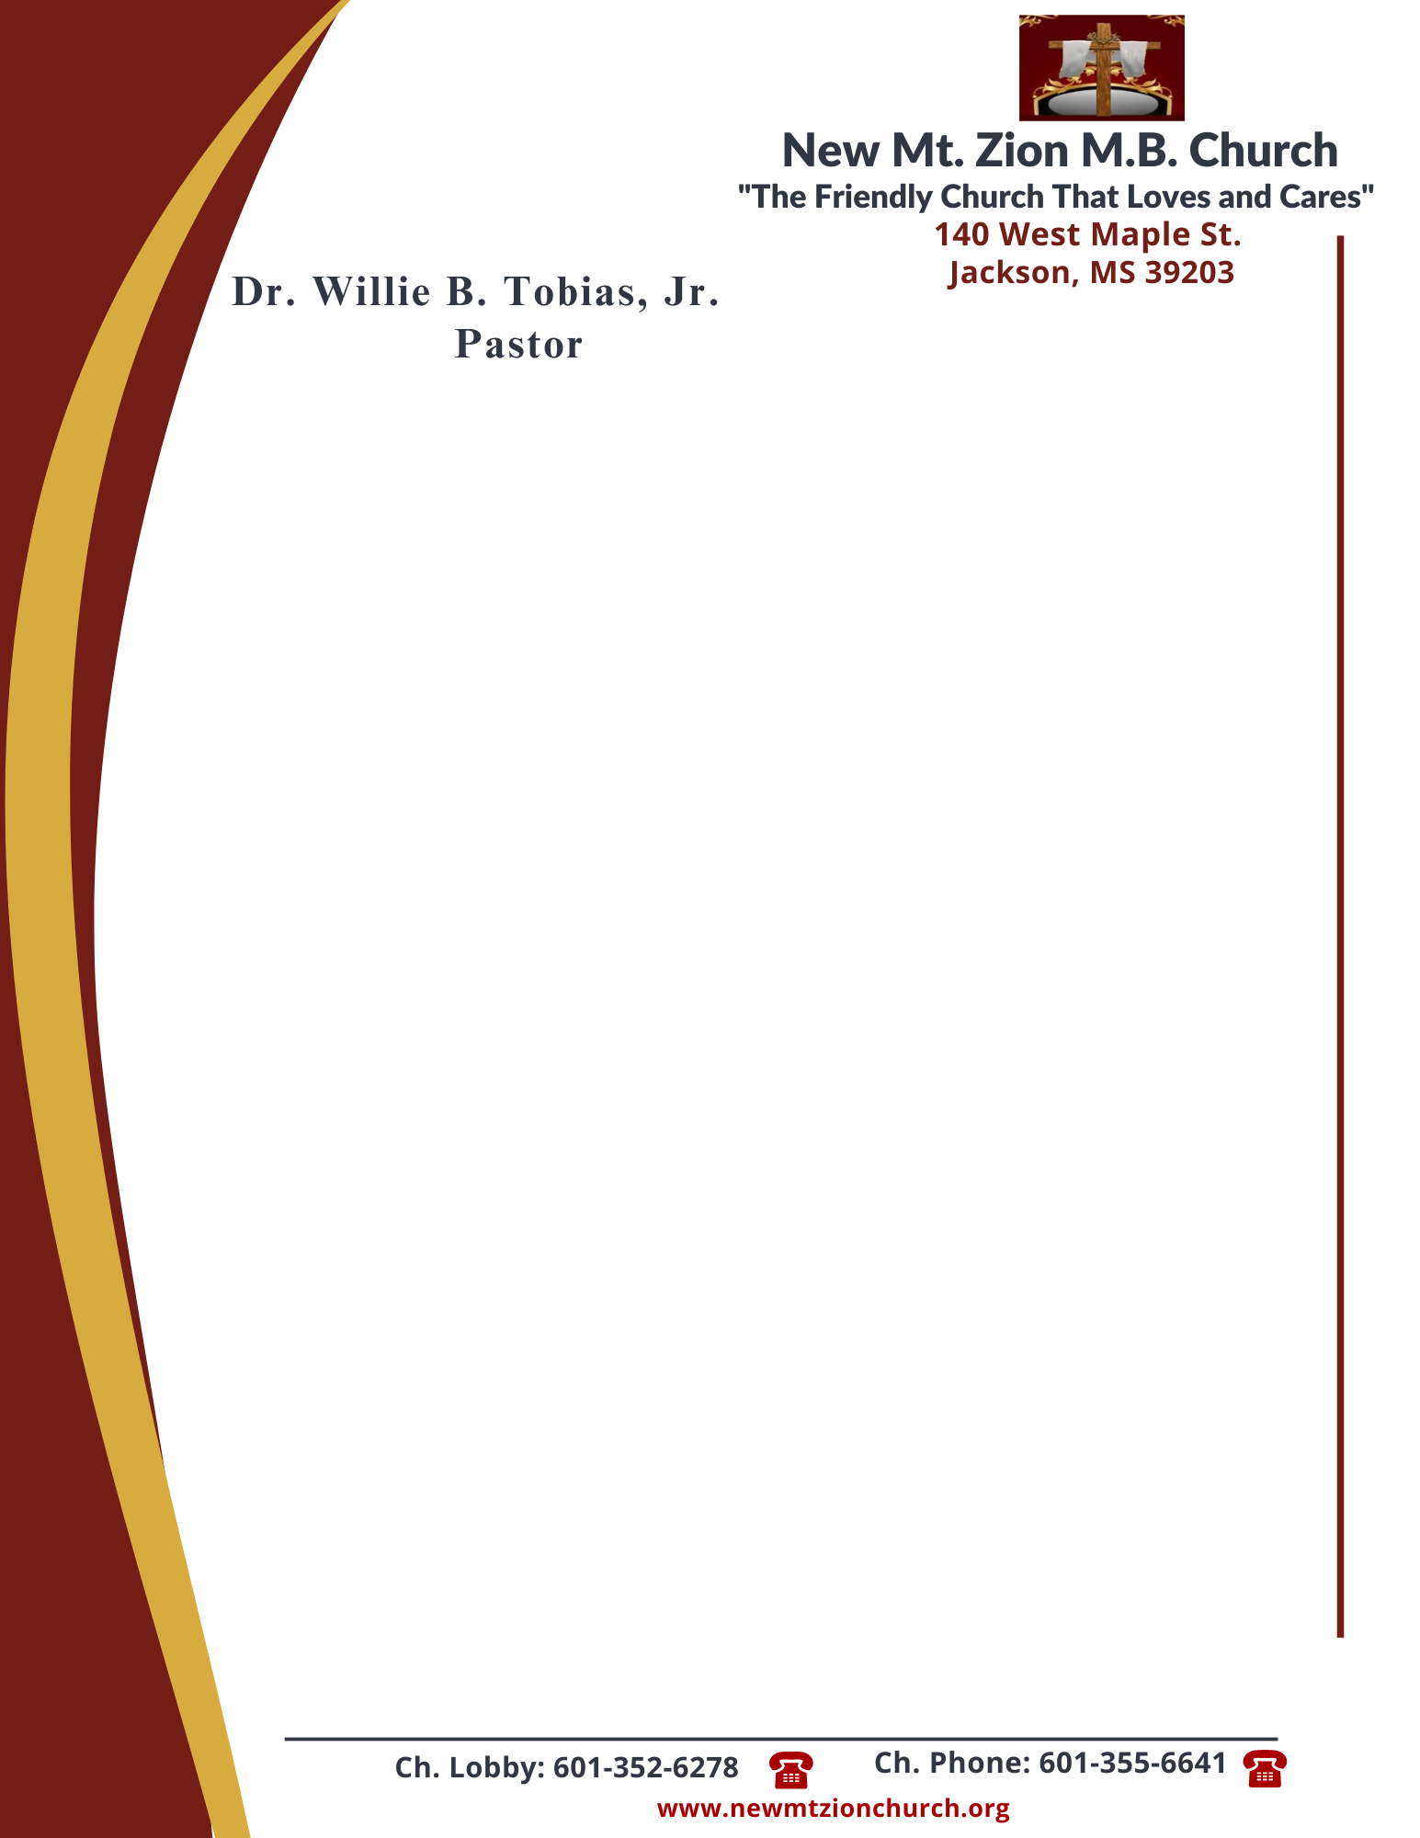

June 26, 2023
“Acting on Faith in God’s Word”
Exodus Chapter 12:24-34

Exodus Chapter 12, the Lord explained the feast of unleavened bread, or Passover, which would become a memorial to the Lord’s deliverance of Israel from bondage in Egypt. The ordinance of the Passover would help the Israelites look forward to the Messiah’s coming and the deliverance of God’s children from spiritual death.

1. How were God’s Instructions significant for Israel’s future, verses 24-27? What can you do today to follow God’s instructions for your life? (Sis. Crystal Williams)

2. How did the Israelites respond to Moses and Aaron in verse 28? (Sis. Carolyn Miller)

3. What happened at midnight in Egypt and what was the final result of Pharaoh’s hardened heart against God, verses 29-30? (Sis. Valencia Tyler)

4. How long did it take for Pharaoh to summons Moses and Aaron? What was Pharaoh’s command to Moses, verses 30-32? (Sis. Ellen Pullum)

5. In reading verse 33-34, what was the Egyptians attitude toward the command of Pharaoh to leave? What did the Israelites do when the people asked them to leave the land? What did they pack and why didn’t they put leaven in the dough? (Bro. Malcolm Dodd)

