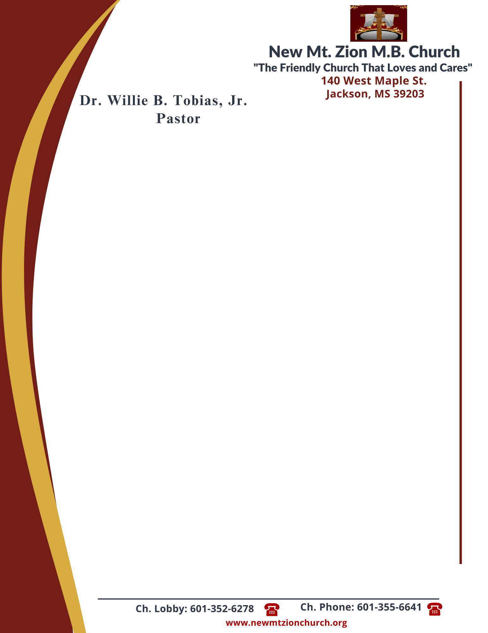

June 12, 2023
“Acting on Faith in God’s Word”
Exodus Chapter 12:14-30

Exodus Chapter 12, the Lord explained the feast of unleavened bread, or Passover, which would become a memorial to the Lord’s deliverance of Israel from bondage in Egypt. The ordinance of the Passover would help the Israelites look forward to the Messiah’s coming and the deliverance of God’s children from spiritual death.

1. Why did God want bread prepared in a certain way, verses 14-15? ( Sis. Elaine Levy)

2. In verses 16-20, what were God’s instructions about the Feast of Unleavened Bread? What has God done to ensure that we know what His instructons are? Why do some people refuse to listen and obey God? ( Rev. Herbert Broome)

3. What did Moses tell the the elders of Israel, verses 21-23? (Sis. Deborah Newson)

4. How were God’s Instructions significant for Israel’s future, verses 24-27? What can you do today to follow God’s instructions for your life? (Sis. Crystal Williams)

5. How did the Israelites respond to Moses and Aaron in verse 28? (Sis. Carolyn Miller)

6. What happened at midnight in Egypt and what was the final result of pharaoh’s hardened heart against God, verses 29-30? (Sis. Valencia Tyler)

