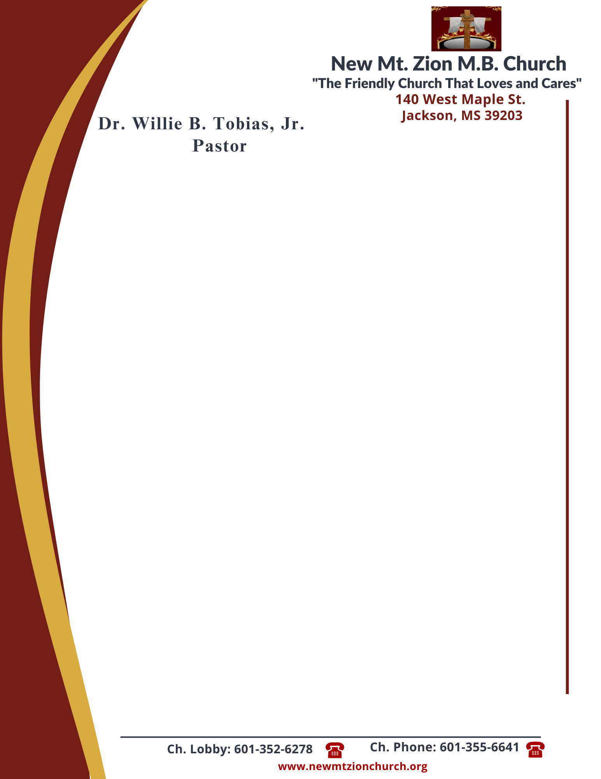

June 5, 2023
“Acting on Faith in God’s Word”
Exodus Chapter 12:3-23

Exodus Chapter 12, the Lord explained the feast of unleavened bread, or Passover, which would become a memorial to the Lord’s deliverance of Israel from bondage in Egypt. The ordinance of the Passover would help the Israelites look forward to the Messiah’s coming and the deliverance of God’s children from spiritual death.

1. After reading verses 3-6, briefly describe the instructions that the Lord commanded regarding the Passover? How long did it take to get ready for the Passover feast? How did this time of preparation serve as a time of reflection and devotion? (Rev. Venus Jones)

2. What were God’s instructions about how the Passover meal was to be eaten? What did it symbolize? Why do you think that there was not to be anything left of the Passover lamb by morning, verses 7-11? (Deacon Esther McCoy)

3. According to verses 12-13, what spared the people of Israel and made them acceptable? How is spreading the blood on the doorposts an act of faith and obedience? What will God do for those who trust Him and His commands? (Deacon Dennis McCollum)

4. Why did God want bread prepared in a certain way, verses 14-15? ( Sis. Elaine Levy)

5. In verses 16-20, what were God’s instructions about the Feast of Unleavened Bread? What has God done to ensure that we know what His instructons are? Why do some people refuse to listen and obey God? ( Rev. Herbert Broome)

6. What did Moses tell the the elders of Israel, verses 21-23? (Sis. Deborah Newson)

